**FIGMA DOCUMENTATION: TEAM 6**

**HackStad is a comprehensive platform designed to streamline the process of hackathon hosting, participation, and management. The platform provides a centralized hub for both organizers and participants, allowing for efficient coordination and tracking throughout the event lifecycle.**

**LANDING PAGE**

The landing page for HackStad should make a strong first impression and clearly communicate the platform's purpose

**HOME PAGE**

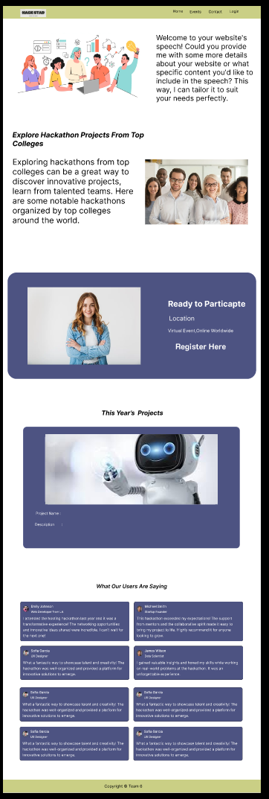The Home Page of HackStad should provide users with a comprehensive overview of the platform's offerings while facilitating easy login or registration**.**

**1. Header**

* Logo and navigation links (e.g., Home, About, Register , Contact).
* Login/Sign-Up buttons prominently placed for quick access.

**2. Hero Section**

* Brief description: "Connecting students, colleges, and hackathon enthusiasts with seamless event management."
* CTA Buttons: “Login”, “Register Now”.

**3. About HackStad**

* A short explanation about what HackStad is, what it offers to students and colleges, and why it’s the go-to platform for hackathon management.

**4. Login/Register Section**

* Simple forms for Login and Registration.
* Quick links for students and colleges to register (differentiated forms if necessary).
* “Login with social accounts” options (e.g., Google, LinkedIn, GitHub) for convenience.

**5. User Reviews/Testimonials**

* A section for reviews from users (students, colleges, organizers) praising their experiences with HackStad.
* Include star ratings, user images, and brief testimonials to build credibility and trust.

**6. Footer**

* Quick links to important pages (e.g., Terms & Conditions, Privacy Policy, Help Center)

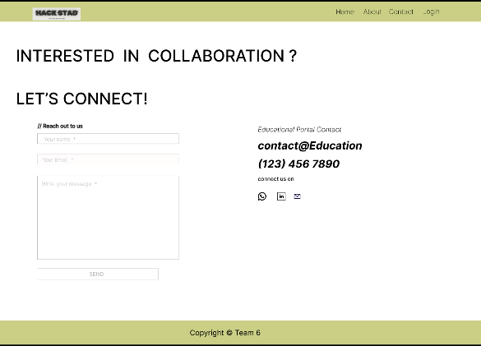**CONTACT PAGE**

The Contact Page for Collaboration on HackStad should be designed to facilitate easy communication for potential partnerships and collaborations.

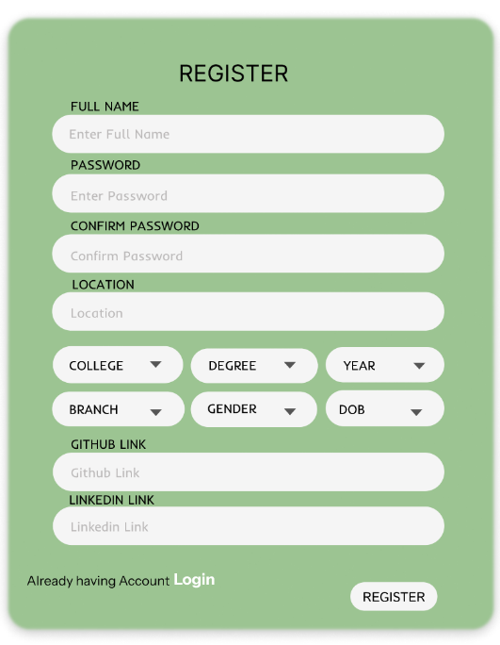**REGISTER PAGE**

For the Student Registration Page and College Registration Page on HackStad, the design should be simple and user-friendly while capturing all necessary information for onboarding

**Student Registration Form Fields**

* Full Name
* Password
* Confirm Password
* College/University Name
* Place/City
* Phone Number
* Year of Study
* 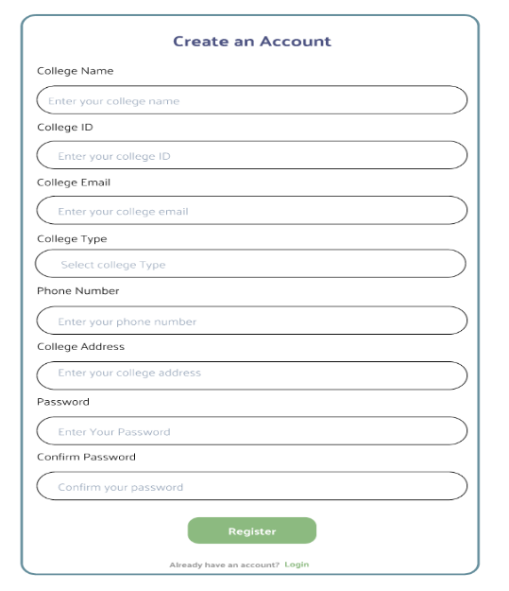GitHub, LinkedIn Ids

**College Registration Form Fields**

* College Name
* College ID
* College Address
* City/State
* Official College Email Address
* Phone Number

**LOGIN PAGE**

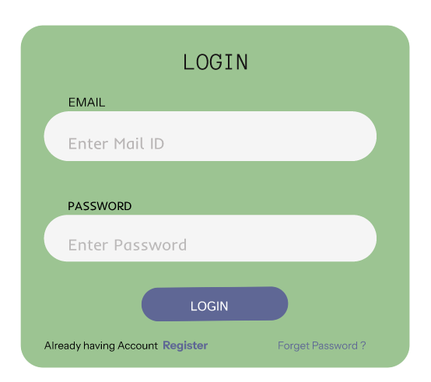The Login Page for HackStad serves as the gateway for students and colleges to access their respective dashboards. Its primary focus is on simplicity, security, and user convenience

**Student Login Page**

**Login Form Fields**

* Email Address
* Password
* 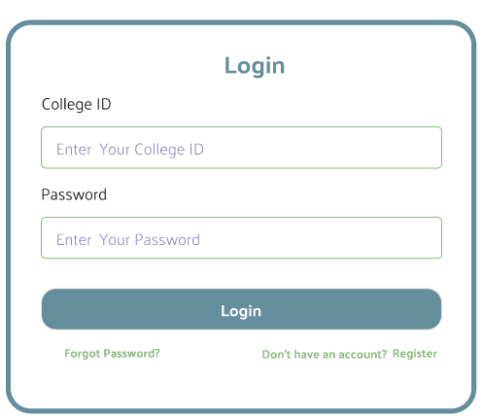**Login** button
* Forgot Password? (Link for students to reset their password via email)
* Don’t have an Account? Register

**College Login Page**

* College ID
* Password
* **Login** button
* Forgot Password? (Link for college admins to reset the password via email)
* Don’t have an Account? Register

**Mentor Login Page**

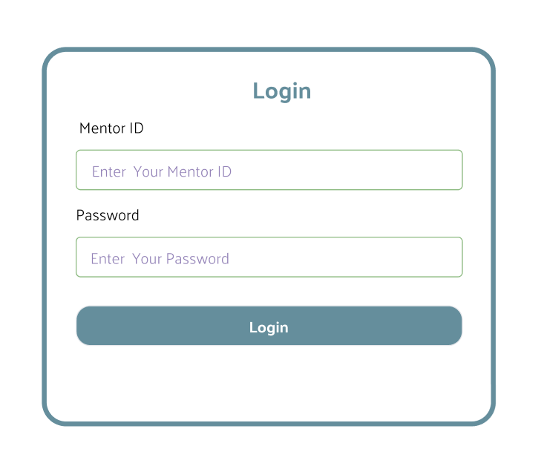The Mentor Login Page for HackStad will allow mentors to securely access their dashboards using their credentials.

* Mentor ID
* Password
* **Login** button

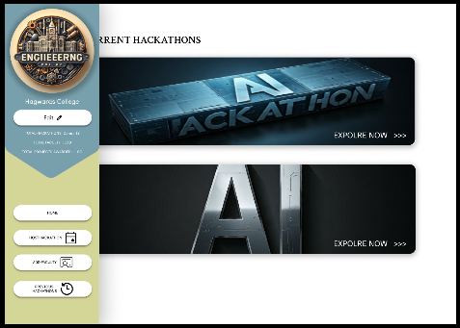**College Dashboard**

The College Dashboard provides a centralized system for colleges to efficiently manage hackathon events, assign mentors, and keep track of both live and past hackathons.

**Home Tab**

* 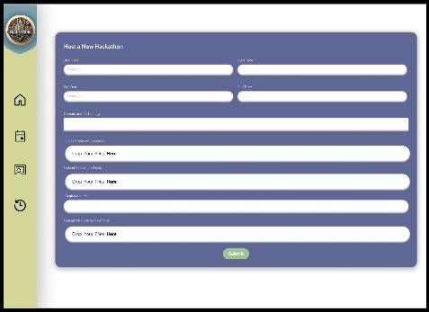Displays the live hackathons hosted by the college. College management can monitor ongoing events, track participation, and manage live operations from this section.

**Host Hackathon Tab**

* The area where the college can start a new hackathon by entering the necessary details such as event dates, theme, rules, and participation criteria. This tab allows for smooth setup and launch of new events.

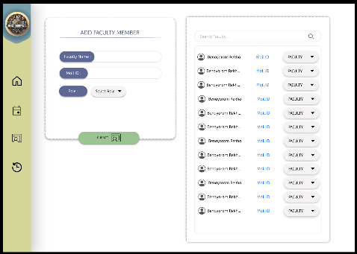**Add Faculty Tab**

* Allows the college to assign mentors and faculty members to evaluate project submissions. Faculty can also guide students through an integrated chat feature and conduct quizzes for participants to test their knowledge and skills during the hackathon.

**Previous Hackathon Tab**

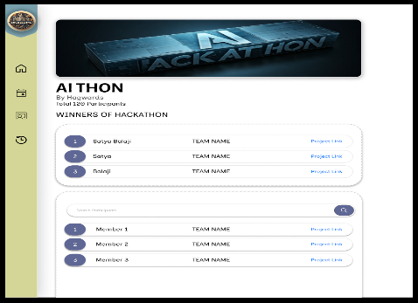

* Lists all the hackathons hosted by the college, including details about the events, participants=pp. This serves as a historical reference for the college’s hackathon management.

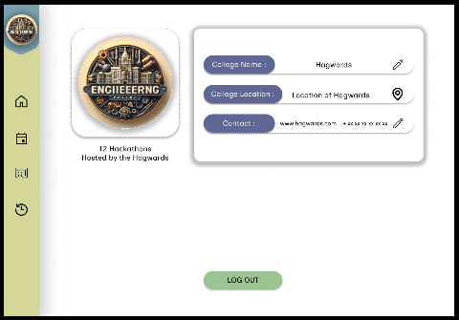

There is an **Edit Button** allowing colleges to modify their details, such as address, contact information, or faculty assignments. Additionally, a **Logout Button** is provided, which takes users back to the website's home page for easy navigation.

**User Dashboard**

**Dashboard Content**

* **Enrolled Events**: A section listing the hackathons the user is currently participating in.
* **Past Events**: A section that shows previous hackathons the user has participated in, with options to view event outcomes, project details, certificate.

**Header Menu**

* **Resources**: A section with learning materials such as tutorials, articles, videos, and documentation to help participants improve their skills.
* **Compiler**: An integrated code compiler allowing users to write and compile their code directly on the platform, providing a sandbox environment for testing.
* 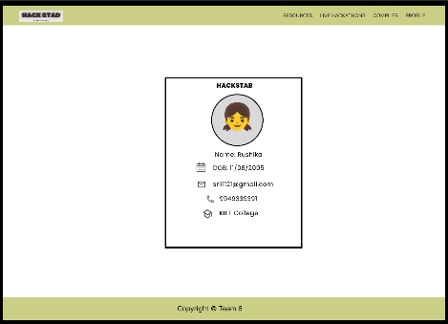**Live Hackathons**: A list of hackathons currently being hosted by different colleges. Users can view event details and enroll directly by submitting the required information.
* **Profile**: Takes users to their profile page where they can update personal information.The Profile Tab not only contains personal details but also features a **HackStad ID**. Users can generate an ID Card.

**Team Dashboard Button**

* **Team Dashboard**: A button that redirects users to a separate dashboard where they can manage their hackathon teams. This could include viewing team members, roles, project progress, and team collaboration tools.

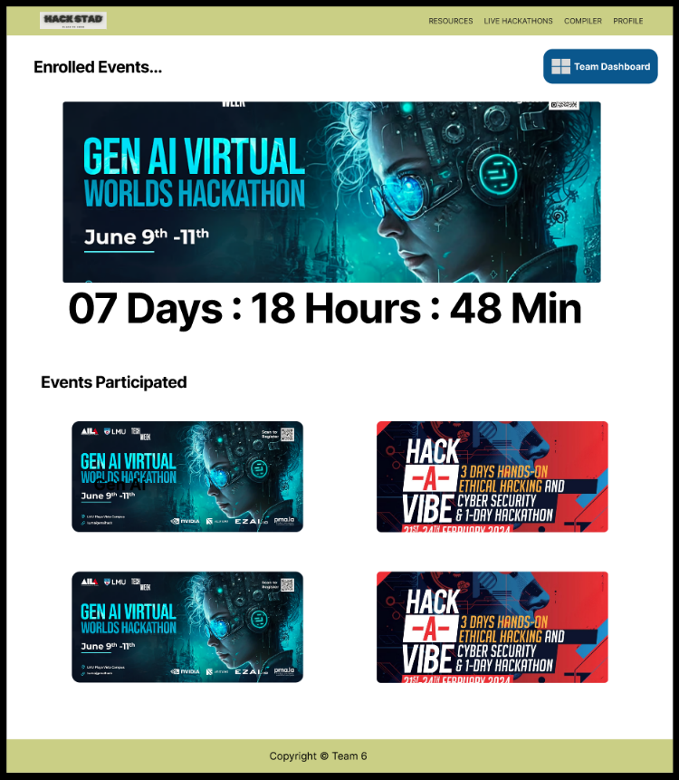

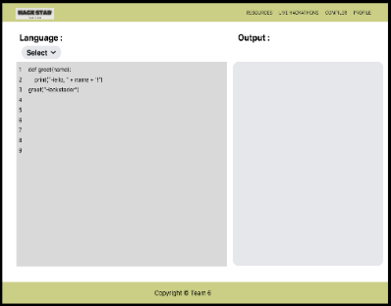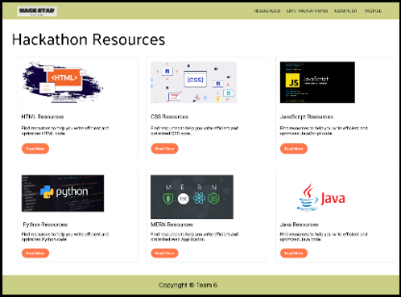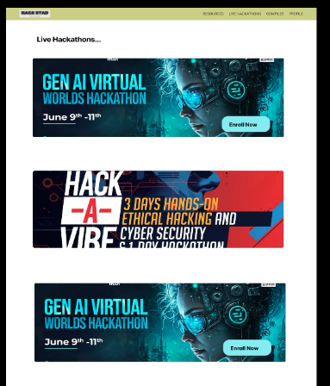

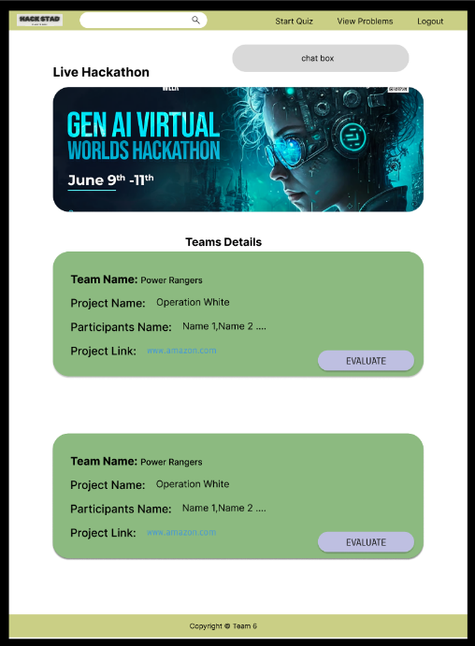**Mentor Dashboard**

The Mentor Dashboard in HackStad provides mentors with various tools to effectively guide participants and manage hackathon activities.

**View Problem Statements Tab**

* Mentors can access and review the problem statements assigned for the specific hackathon. This helps them understand the challenges participants are working on and offer relevant guidance.

**Quizzes Tab**

* Mentors have the option to create and host quizzes for hackathon participants. These quizzes can assess participant knowledge or serve as part of the hackathon's learning and evaluation process.

**Project Evaluation**

* Mentors can evaluate submitted projects by teams or individual participants. There are two outcomes for each evaluation:
  + Accept: If the project is accepted, the mentor assigns a score based on performance.
  + Reject: If the project is rejected, the mentor provides a comment explaining the reason for rejection, offering constructive feedback.

**Logout Button**

* 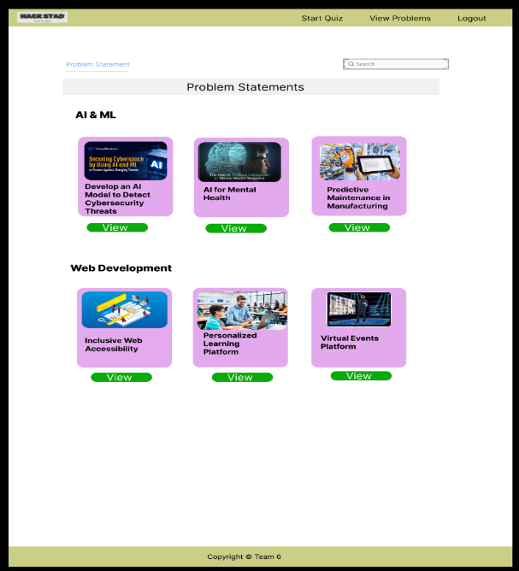A simple Logout Button allows mentors to exit the dashboard and return to the website's homepage.

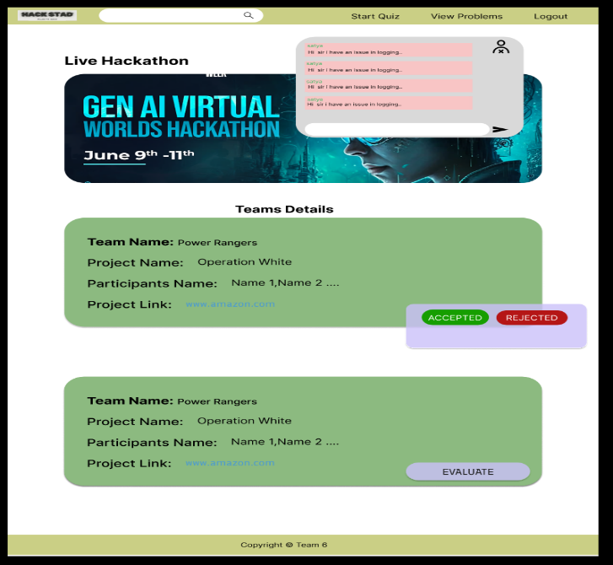**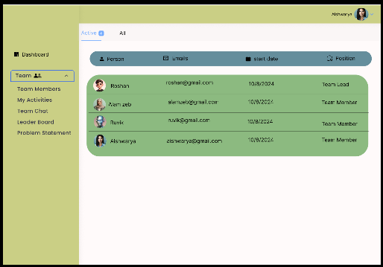Team Dashboard**

The Team Dashboard offers a collaborative space for effective project management, communication, and competition tracking, providing all the essential tools for a hackathon team.

**Team Members Tab**

* Displays the list of all team members with details like their names, roles, and contributions to the project.

**My Activities Tab**

* Allows individual team members to track their time spent on the platform and overall productivity.

**Team Chat Tab**

* An integrated chat feature enabling real-time communication between team members and mentors. It supports direct messaging, group discussions, and the ability to share files or links related to the hackathon project.

**Leaderboard Tab**

* Provides a competitive overview of the status of other teams, showing which teams have submitted their projects and their current standings. This motivates teams to track their progress in real-time.

**Problem Statement Tab**

* A section where teams can browse and select the problem statement for their hackathon project. This ensures clarity on the project objectives and the problem they are solving

There's also a **Logout** Button that allows users to easily return to the User Dashboard, providing a seamless navigation experience between different sections of the platform.

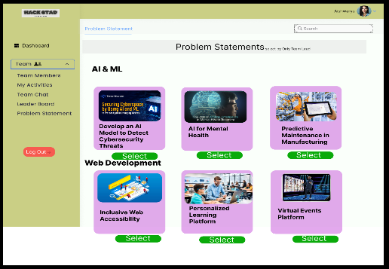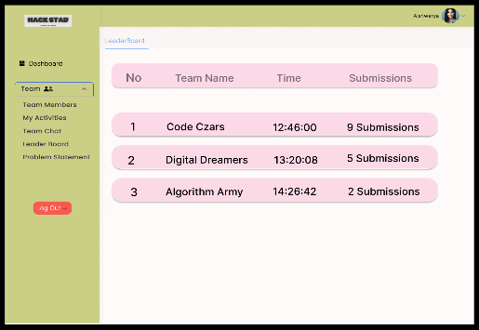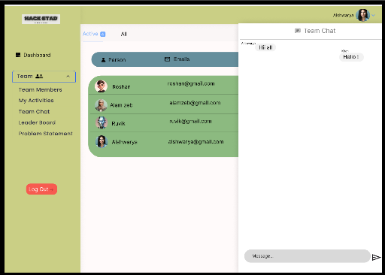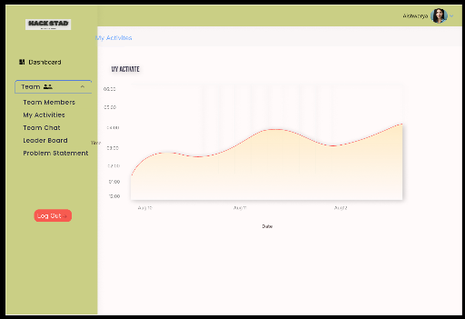Thank You…

From Team 6…